Tab 1
Project Documentation
LIBSPACE
TEAM LEADER:
- Devika R (devika24.rajendran@gmail.com)
TEAM MEMBERS:
-Srinithi R (srinidhiravi20@gmail.com)
-Keerthana R (kr6712460@gmail.com)
-Shiny Hema K (stellashiny.4088@gmail.com)

PROJECT OVERVIEW
| The ConnectHub is a backend web application designed to solve the common problem of I scattered contact information across multiple platforms.
It provides users with a centralized, I organized system to store, search, and categorize their professional and personal contacts.
Key Objectives:
Provide secure user authentication and data isolation
Enable efficient contact management through CRUD operations
Implement flexible categorization using tags
Offer fast search and filtering capabilities
Deliver a responsive, cross-device user experience
| Target Users:
1
1
3 Initialize Node Project
Run: npm init -y
This will create a package.json file.
Install Required Dependencies
Install Express:
npm install express
npm install mongoose
For development (auto-restart server):
npm install nodemon --save-dev I
5 Create Basic Server File
Inside the server folder:
Create a file called: server.js
Add this code :
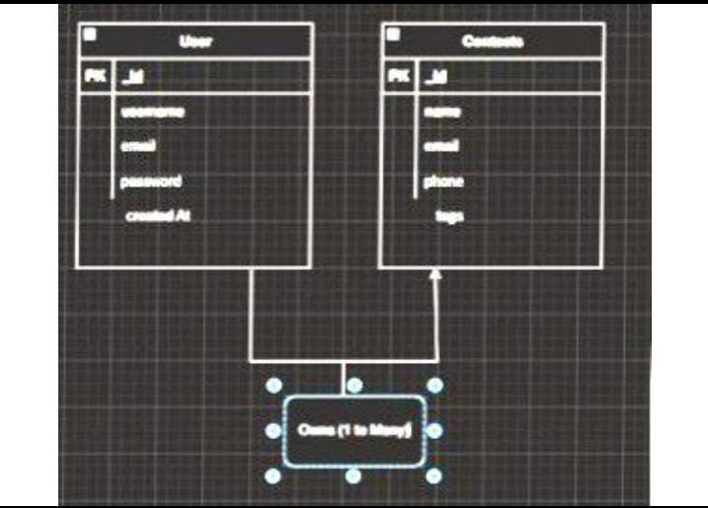
Real-time Search
L
Debounced search across name, email, and tags with instant results T
Roles and Responsibility
• User -

1.-Registration-Register on the application using the name, email, +
password-
-
2. Login Login on the application using the email and registered passw 13. Search Search for a contact using name, email or tags.
14. Add Contact
Add new contact name, email, phone, notes, tags | 5. Edit Contact Edit the existing contact
6. Delete Contact Delete any contact
User Flow

router.get('/search', authentication, searchContacts);
router.route('/')
.get(authentication, getContacts)
.post(authentication, contactvalidation, validate, createContact);
router.route('/:id')
.get(authentication, getContactById)
.put (authentication, updateContactvalidation, validate, updateContact) .delete(authentication, deletecontact);
Implement Data Models:
Define Mongoose schemas for the different data entities like user
and contact
Create corresponding Mongoose models to interact with the
MongoDB database.
Implement CRUD operations (Create, Read, Update, Delete) for each
model to perform database operations.
L-import mongoose-from "mongoose"
import bcrypt from 'bcryptjs
const userSchema
name: [
type: String,
new mongoose.Schema(
required: [true, 'Please add a name'],
trim: true,
email: (
type: string,
required: [true, 'Please add an email'],
unique: true,
lowercase: true,
trim: true,
match: [
1.
/^\wi([\. ]?\w+)*@\w+ ([\. ]?\w+)*(\.\w(2,3))$/,
'Please add a valid email',
password: (
type: string,
required: [true, 'Please add a password'],
minlength: 6,
select: false,
timestamps: true,
Γ
const contactSchema new mongoose.Schema(
{
userId: {
},
type: mongoose.Schema.Types.ObjectId,
required: true,
ref: 'User',
name: {
},
type: String,
required: [true, 'Please add a contact name'],
trim: true,
email: 0
type: string,
trim: true,
lowercase: true,
match: [
/^\w+([\-]?\w+)*@\w+([\-]?\w+)*(\.\w{2,3})+$/, 'Please add a valid email',
57.
phone: {
type: string,
trim: true,
),
tags: {
type: [string],
default: [],
},
},
{
timestamps: true,
Error Handling:
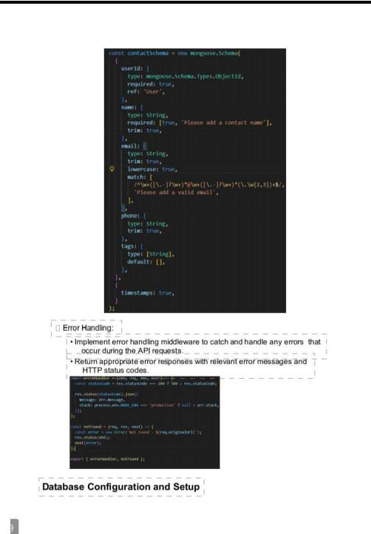
Implement error handling middleware to catch and handle any errors that
occur during the API requests.
Return appropriate error responses with relevant error messages and
HTTP status codes.
coast-errorHandler(err, req, res, next)-
const statusCode res.statusCode 2007 500: res.statusCode;
res.status(statusCode).json({
message: err.message,
stack: process.env.NODE_ENV
production? null: err.stack,
const notFound (req, res, next)
(
const error new Error('Not Found $(req.originalurl)');
res.status(404);
next(error);
export (errorHandler, not Found };
Database Configuration and Setup
1
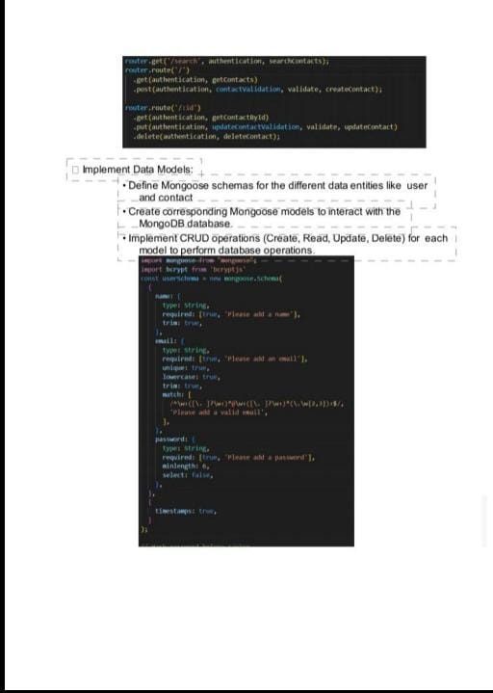
1. Configure MongoDB:
Install Mongoose
IT Create database connection.
Create Schemas & Models.
2. Connect database to backend:
Now, make sure the database is connected before performing any of the actions through the
backend. The connection code looks similar to the one provided below.
const PORT process.env.PORT || 6001;
mongoose.connect(process.env.MONGO URL,
uselier 1Parser: true,
uselnifiedTopology: true
}).then(()->{
server.listen(PORT, ()->{
console.log("Running @SPORT)");
}).catch((err)->{
console.log("Error: ", err);
୮
3. Configure Schema:
Cherje
Firstly, configure the Schemas for MongoDB database, to store the data in such pattern. Use the data from the ER diagrams to create the schemas.
The schemas are looks like for the Application.
server models Users
import mongoose
const Userscha
mongoose, Schema((
type
String.
require: true
type: String.
require: trsie, unique: true
password:[
type: String.
require: true
const User-songoose.model("users", UserSchens); export default User;
Project Execution
Execution Steps
|||
1. Open the project folder in the terminal
2. Make sure you have a start script in the package.js file 3. Use the command npm start to start the server 14. You will the Running on PORT message on the
successfully starting the server
5. You will also see the database connected message if
the database is connected successfully T
6. Use the Thunder client or Postman for using the
created api's T
Output Screenshts 1.post login
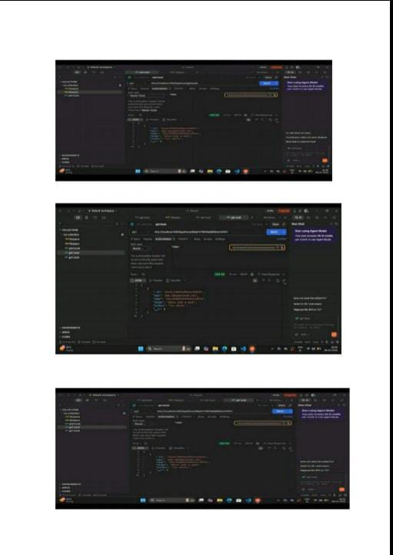
2 post add book



Tab 2

